JOHN JACKSON – FOOTBALLER
Tony Hill, who runs the Leeds United History website on www.ozwhitelufc.net.au in Australia contacted George McGrattan who runs the www.ArdrossanFootballClubs.net website. He wanted information on a footballer called John Jackson who played for Leeds between 1913 and 1915. An extract from the enquiry is ‘Many sources have accepted the dates of birth and death of the player as being for a John Bertram Jackson as 21 June 1893 at Dalry, Ayrshire and 8 August 1971 at Glasgow. There is no doubt that such a person existed, but, in our opinion, it was not the John Jackson of Clyde and Leeds City fame!’

The name John Jackson was not one with which I was familiar so I did some internet research and found some information on him. I found an extract from the 1911 census, shown below, that showed he was a twenty-two year old professional football player, born in Irvine around 1889.
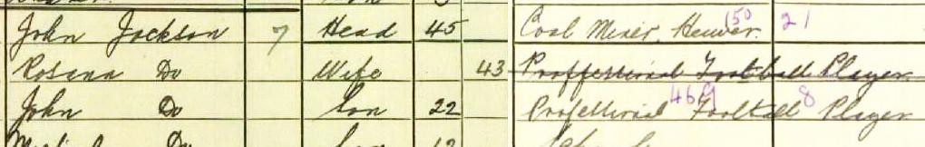
This information should have made it easy to find John’s birth certificate on Scotland’s People, the repository of all Scottish births, marriages and deaths since 1855. Unfortunately, an online search proved fruitless. In mid-April 2019, I visited Scotland’s People in Edinburgh and again was unable to find John’s birth record although he and his parents and siblings were listed in the 1891, 1901 and 1911 censuses. I was, however, able to find his marriage certificate.
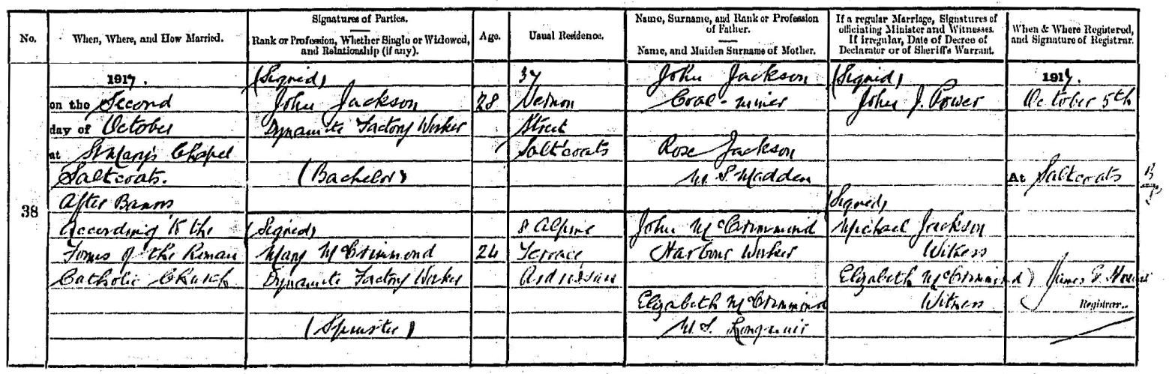
It shows that John Jackson and Mary McCrimmond on 2 October 1917 were married in Saint Mary’s Church, Saltcoats by Father John Power. Both were dynamite factory workers with Nobel’s Explosives Company in nearby Stevenston. It appears that John had retired from full-time football.
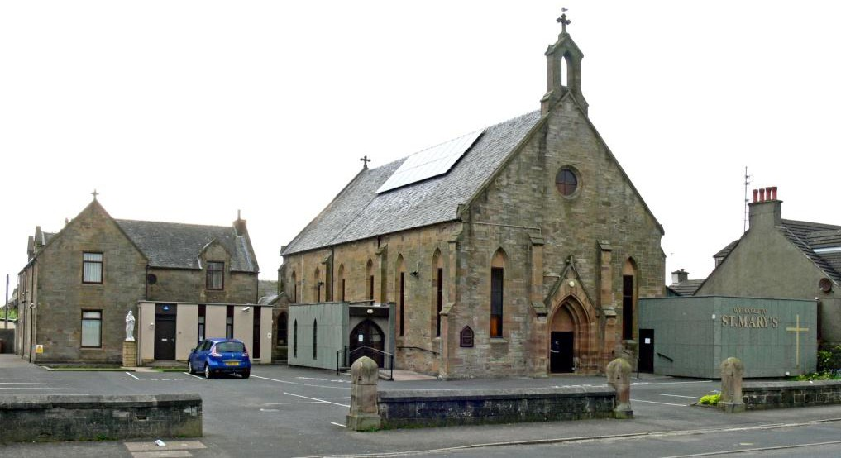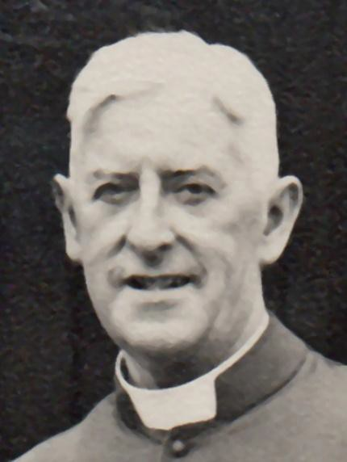
Saint Mary’s Church, Saltcoats John Power

I also found his parents’ marriage certificate.
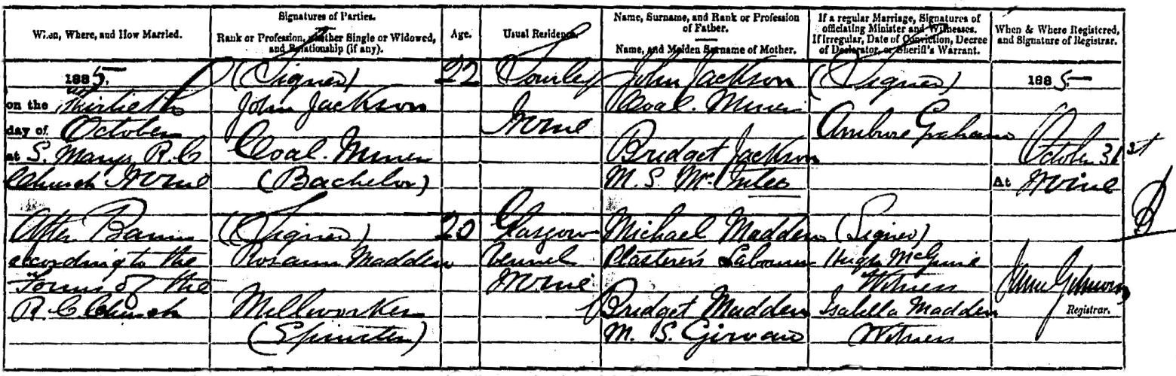
It shows that John Jackson, a coal miner, married Roseann Madden, a mill worker, on 30 October 1885 in Saint Mary’s Church, Irvine.
Most football documents that refer to John Jackson’s age suggest he was born around 1890 and his marriage certificate and the 1911 census extracts confirm this. The 1891 and 1901 censuses, however, suggest that he was born around 1885 so I searched for a child born to Roseann Madden and was delighted to find the certificate below.
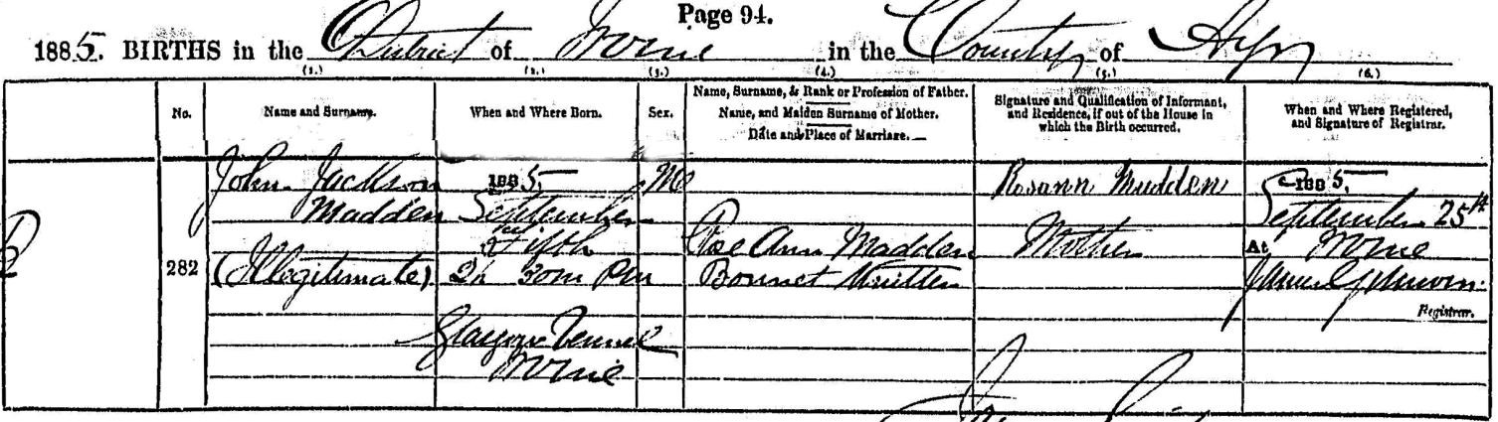
It shows that John Jackson Madden was born on 5 September 1885, eight weeks before his parents’ marriage. It appears that while his father was not named on the certificate, Roseann identified him by giving her son the forenames John Jackson – which has proved very helpful for my research!
Incidentally, John was born at a street called Glasgow Vennel in Irvine, where a hundred years previously, the world-famous Scottish poet, Robert Burns, worked in a flax mill.
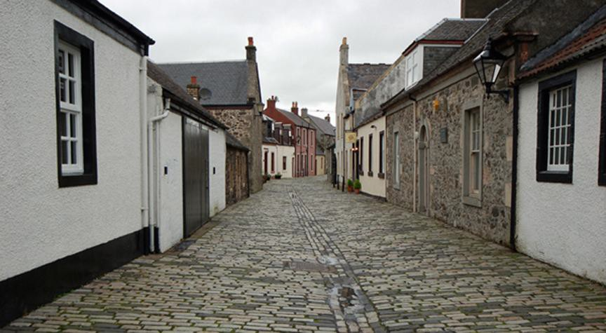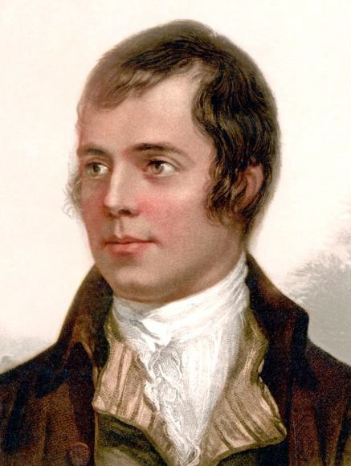
Glasgow Vennel, Irvine Robert Burns
It is interesting to note that in his adult life, John was four or five years older than was claimed. Whether John was aware of his birth circumstances is not known. He gave his age as 28 when he married in 1917 suggesting that he was born in 1889 while he was actually born in 1885.
Hopefully, this research solves the mystery of John Jackson’s birth and is of some value.
George McGrattan 18 April 2019

