JOHN JACKSON – FOOTBALLER

Tony Hill, who runs the Leeds United History website on www.ozwhitelufc.net.au in Australia contacted George McGrattan who runs the www.ArdrossanFootballClubs.net website. He wanted information on a footballer called John Jackson who played for Leeds between 1913 and 1915. An extract from the enquiry is ‘Many sources have accepted the dates of birth and death of the player as being for a John Bertram Jackson as 21 June 1893 at Dalry, Ayrshire and 8 August 1971 at Glasgow. There is no doubt that such a person existed, but, in our opinion, it was not the John Jackson of Clyde and Leeds City fame!’

The name John Jackson was not one with which I was familiar so I did some internet research. I targeted a publication called The Scottish Referee, a football newspaper of the late nineteenth and early twentieth centuries. As well as featuring prominent senior clubs, it also reported on the lower ranks. I found the following five references to John Jackson.

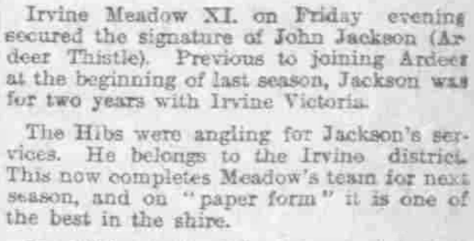
16 July 1909

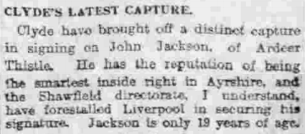
30 August 1909

The above extracts state that Jackson belonged to the Irvine area and was nineteen years old, implying birth around 1890. He could not have played many games for Irvine Meadow as he left six weeks after signing.
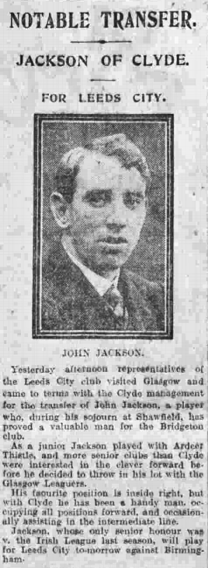
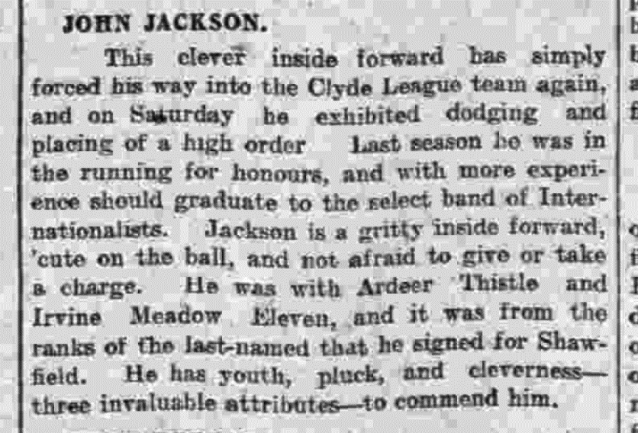
1 October 1910

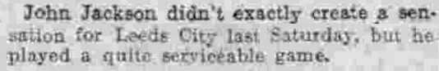
26 December 1913

Further affirmation of John Jackson’s year and place of birth was found in the book Football League Players’ Records 1888 to 1939. This lists the career records of all players who appeared in at least one match in the English Football League between the stated years. John was noted to have been born in Irvine in 1890, earned an international cap with the Scottish League and played for Clyde and Leeds City.

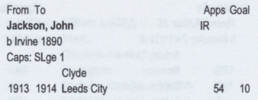
Extract from the Football League Players Records book.

Given this useful information, I thought it would be easy to find his birth certificate on the Scotland’s People website. 19 December 1913
Unfortunately, this proved to be unsuccessful.

I checked the census returns of 1891 and 1901 but could not find a John Jackson with the target attributes.

I was therefore surprised to find him in the 1911 census when he lived in Irvine with occupation Professional Football Player. The extract is shown below and there are more details on the next page.

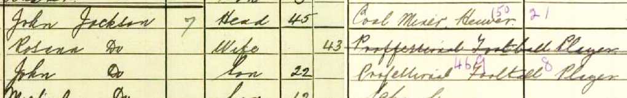
Extract from the 1911 Census of Irvine
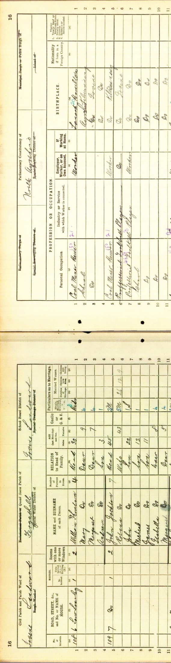 | In summary, it appears that the John Jackson who played for Leeds was not John Bertram Jackson born on 21 June 1893 at Dalry. It is disappointing that I cannot find his birth certificate but that might be due to inadequacy on my part.  Some of this information may have been known to Tony before his enquiry. Regardless, I hope that it is of use and helps in some way to answer his question.  George McGrattan 6 February 2019
Extract from the 1911 Census of Irvine

